Hi everyone!

I am highly delighted to share my first Excel project with you all on this platform.  
Earlier This month (September), I made a decision to embark on a journey to effect adequate mastery and unravel mysteries that governs the use of Excel and how it is applicable to Data Analysis with the sole aim of closing out with a piece of project to practice my acquired skills.

# ****Project Overview****

This project is aimed at improving my Excel skills through practice done by using this project to analyze the Bike Sales dataset so as to derive a data-driven customer insights.

# ****Dataset description****

The Bike Sales dataset can be gotten using this link:

[https://github.com/AlexTheAnalyst/Excel-Tutorial/blob/main/Excel%20Project%20Dataset.xlsx](https://github.com/AlexTheAnalyst/Excel-Tutorial/blob/main/Excel Project Dataset.xlsx" \t "/private/var/folders/bv/1cgyzt516lgfk8l0mhd0fnnm0000gn/T/com.kingsoft.wpsoffice.mac.global/wps-mac/x/_blank)

**[Excel-Tutorial/Excel Project Dataset.xlsx at main · AlexTheAnalyst/Excel-Tutorial](https://github.com/AlexTheAnalyst/Excel-Tutorial/blob/main/Excel Project Dataset.xlsx?source=post_page-----b566292c2fc0--------------------------------" \t "/private/var/folders/bv/1cgyzt516lgfk8l0mhd0fnnm0000gn/T/com.kingsoft.wpsoffice.mac.global/wps-mac/x/_blank)**

[Contribute to AlexTheAnalyst/Excel-Tutorial development by creating an account on GitHub.](https://github.com/AlexTheAnalyst/Excel-Tutorial/blob/main/Excel Project Dataset.xlsx?source=post_page-----b566292c2fc0--------------------------------" \t "/private/var/folders/bv/1cgyzt516lgfk8l0mhd0fnnm0000gn/T/com.kingsoft.wpsoffice.mac.global/wps-mac/x/_blank)

[github.com](https://github.com/AlexTheAnalyst/Excel-Tutorial/blob/main/Excel Project Dataset.xlsx?source=post_page-----b566292c2fc0--------------------------------" \t "/private/var/folders/bv/1cgyzt516lgfk8l0mhd0fnnm0000gn/T/com.kingsoft.wpsoffice.mac.global/wps-mac/x/_blank)

This dataset shows a Bike Sales data of an anonimous company.It comprises of 13 rows and 1027 columns, with several fields such as ID, Marital Status, Gender, Income, Children, Education, Occupation, Cars, Commute distance, Region, Age, Purchased bike.

# ****Research Questions****

i. What is the average income of those who purchased bikes and those who did not, based on their gender?

ii. Does the commute distance affect the purchases of bikes?

iii. What age groups make the most bike purchases?

# ****Data Cleaning and Preprocessing****

Even though the datasets appeared clean to a large extent, still ensured to check thoroughly.

* **Checked for duplicates** (found 26 duplicates and removed them leaving 1000 unique values by using the *Remove duplicates* feature), no missing values was discovered. Replacement of some letters with words ve ambiguities..
* Upon close inspection of each of the columns in the datasets, discovered the important need to replace M with Married and S with Single in the *Marital Status* column, M with Male and F with Female in the *Gender* column, using the Find and Replace feature.This is to prevent any form of ambiguities due to repeated letters. The column Income, was equally cleaned to esnure uniformity of the decimal places using the Format currency feature.
* Created a new column named “Age group” from the *Age column* by using the Nested If statement in the formula:

*=IF(L2>54,”Old (55+)”,IF(L2>=31,”Middle Aged (31–54)”,IF(L2< 31,”Adolescent (18–30)”,”Invalid”)))*

*This made categorisation of the different age groups into a more distinct age bracket, easier.*

# ****Data Visualization****

1. ****Created Pivot table****s and visualized the tables using recommended charts.Using the Insert feature to create the Pivot tables: *Insert tab — Pivot Table — From Table/Range.*

****2. Created Slicer****s — the user friendly buttons or filters in a report or chart that helps easy navigation as one may desire to see. 4 slicers were created; *Marital Status, Religion, Education, Occupation.*

****3. Built an Interactive dashboard****

The generated charts from the pivot tables were put together and slicers were added. Here’s what the final dashboard looks like:

Replacement of some letters with words to remove ambiguities..

**Answers to Research questions (Analysis and Insights)**

1. Average income of Males and Female who purchased bike or not

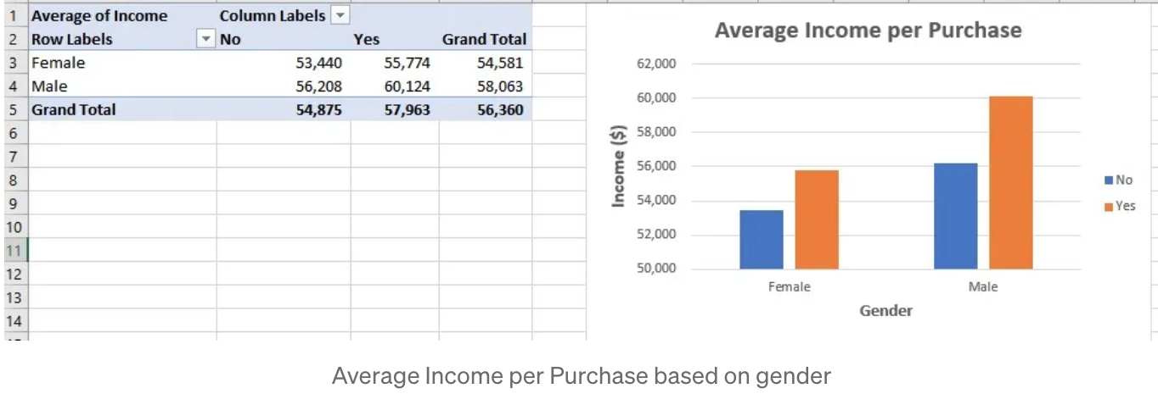

For a clearer inspection and comparison of the average income of Male and Female bike purchasers and non-purchasers, a bar chart was created. The bar charts showed that there are more Male and Female purchasers than non-purchasers. This is a major pointer to a higher average incomes among purchasers. Conversely, individuals with higher incomes are more likely to purchase bikes.

ii. Purchase of bikes based on Customer’s commute distance

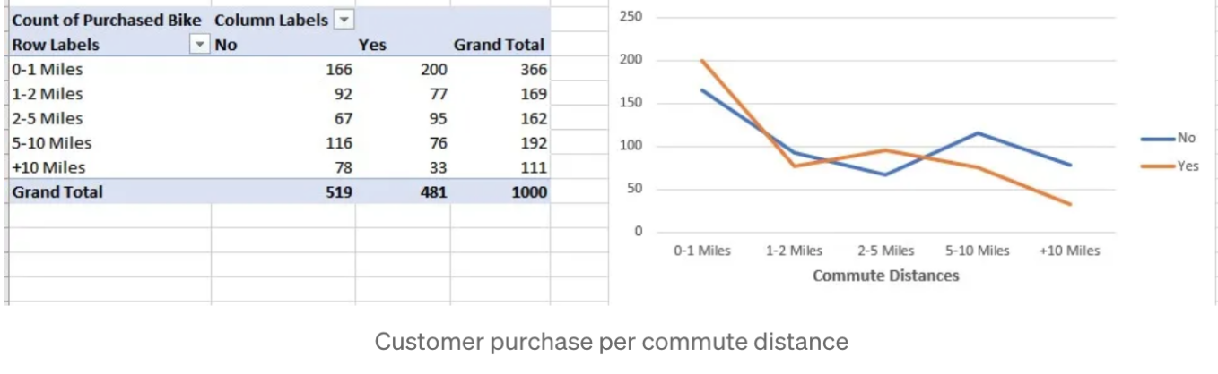

The impact of “Commute distances” on bike purchases was established using a line chart to determine the highest commute distance. Bike purchases were highest at 0–1 miles, 2–5 miles. It is evident that Customers who fall within these ranges shows a higher tendency of purchasing bikes.

iii. Bikes purchase based on Customer’s Age group

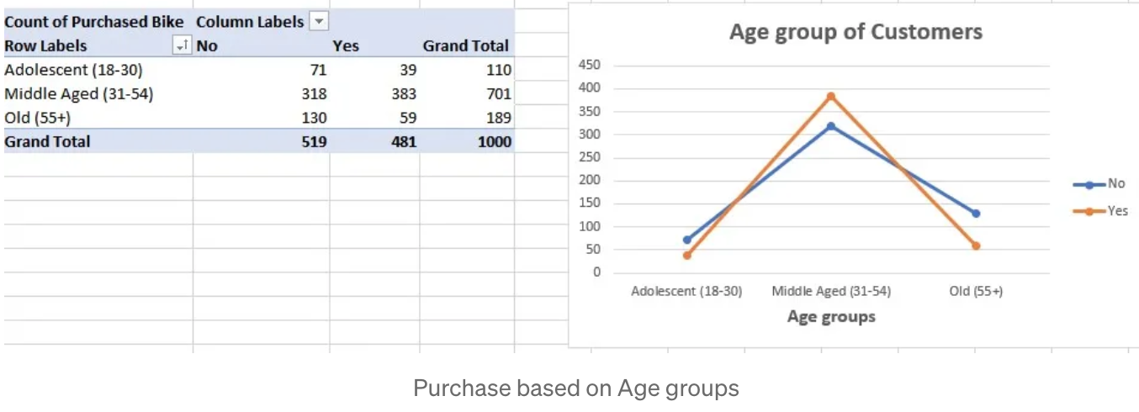

Upon observation of the various age groups, it is evident that Middle-aged customers accounted for the highest bike purchases, indicating a leaning for bike usage amidst this demographic. A clear indication that individuals in this age category are fascinated to biking. Possibly been seen as a fitness option for middle-aged customers or for recreational activities.

**Summary**

* ****Income and Bike Purchase****: High Income individuals have higher tendencies of purchasing bikes. With this discovery, the bike company can then set their targeted market at individuals with higher income.
* ****Commute Distance and Bike Purchase****: The Bike purchases is highest for short commutes (0–1 mile and 2–5 miles). It is highly recommended that biking promotional approach as a convenient solution for short distance.
* ****Age Group and Bike Purchase****: The highest Bike purchases was evident among the Middle-aged customers. Placing much emphasis on the leisure and health benefits during Marketing to this group,is highly recommended.
* Generally, the analysis of this data suggests that the higher-income individuals should be targetted. Promoting biking for short commutes and aggressive marketing to middle-aged customers will further increase bike sales.
* There are several other insights that can be deduced from the dashboard. However, my focus for the purpose of this study is centred upon the emphasised areas only.

Thank you for your time!